**Socket Programming**

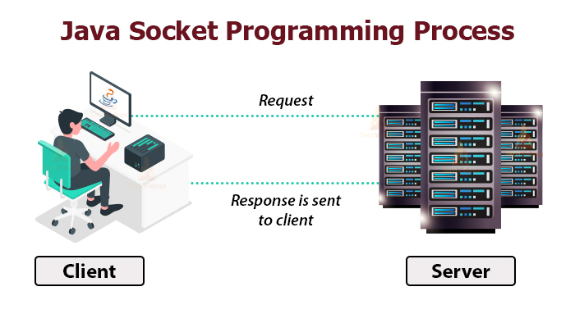

1. **Prerequires JAVA is pre-installed**

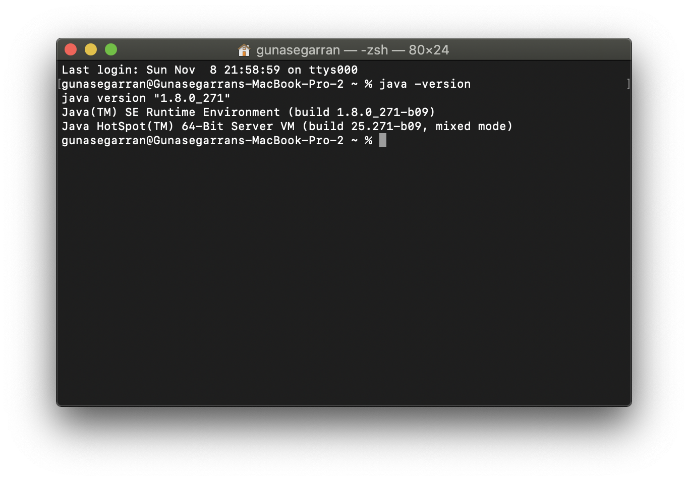

1. **Testing Socket : Client – Server**

A socket in Java is one endpoint of a two-way communication link between two programs running on the network. A socket is bound to a port number so that the TCP layer can identify the application that data is destined to be sent to.

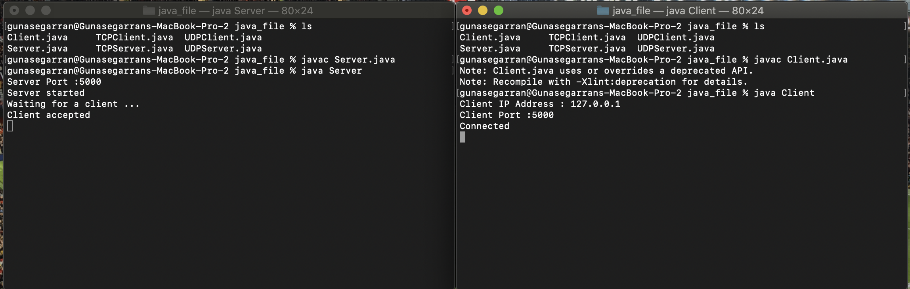

The very first step is to establish a socket connection. A socket connection implies that the two machines have information about each other’s network location (IP Address) and TCP port.

Socket socket = new Socket(“127.0.0.1”, 5000)

* Here, the first argument represents the **IP address of Server**.
* The second argument represents the **TCP Port**. (It is a number that represents which application should run on a server.)

1. **Testing TCP Connection Client Server**

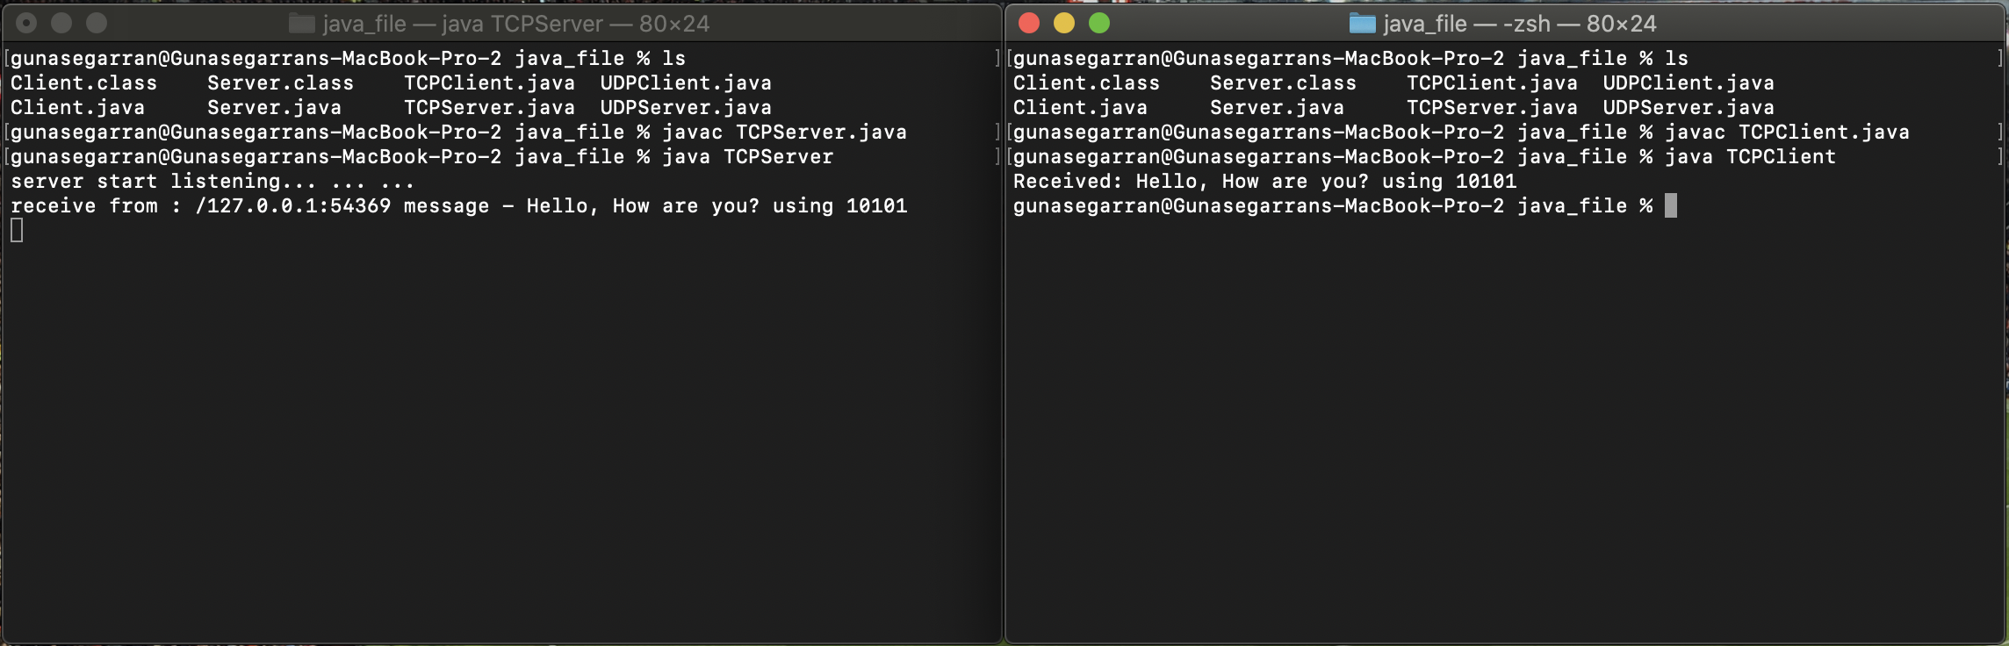

A TCP connection is established with the help of three-way handshake. It is a process of initiating and acknowledging a connection. Once the connection is established, data transfer begins, and when the transmission process is finished, the connection is terminated by the closing of an established virtual circuit.

1. **Testing UDP Connection Client Server**

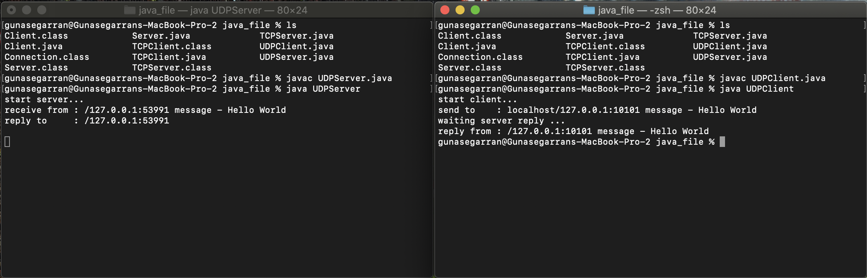

UDP uses a simple transmission method without implied hand-shaking dialogues for ordering, reliability, or data integrity. UDP also assumes that error checking and correction is not important or performed in the application, to avoid the overhead of such processing at the network interface level. It is also compatible with packet broadcasts and multicasting.